Project Of Mid – Bano-Qabil 2.0

Developer : **SAAD-ULLAH KHAN**

Student ID : **24644**

Number : **03002925763**

Project : **Snake – Water – Gun (*Game-based project*)**

**Snake - Water – Gun**

Game-Based Project

**What is this?**

Snake, Water and Gun is a variation of the children's game "rock-paper-scissors" where players use hand gestures to represent a snake, water, or a gun.

**How it works?**

The gun beats the snake, the water beats the gun, and the snake beats the water

**Which Technology is used for development?**

Python programming language is used for development, it is a general-purpose programming language that is used in many areas. It is most popular programming language in the world!

Program Explanation

This program is started by a simple program ‘introduction’ of this game

Here Snippet of ‘introduction’:

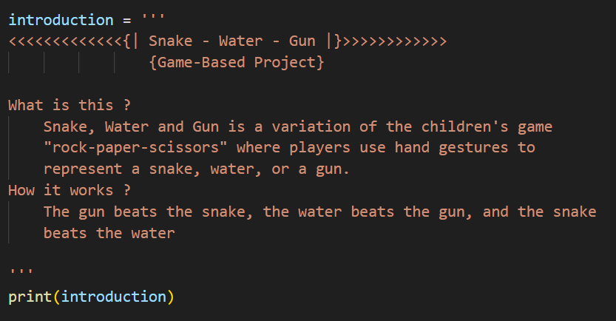

Also we import built-in **random module’s** method **randint()**, it is used to generate computer choice when game is set as single-player mode



This game code has been break in 7 functions to simplify the program and easy to understand. These functions are listed below:

1. game_mode_selection
2. game_round_selection
3. game_logic
4. players_choice_take_and_check
5. single_player_mode
6. multiplayer_mode
7. Results

**1. game_mode_selection(single_player_mode, multiplayer_mode)**

**Purpose:** Allows the user to select the game mode (Single Player or Multiplayer).

**Parameters:**

**single_player_mode:** Function representing the Single Player game mode.

**multiplayer_mode:** Function representing the Multiplayer game mode.

**Usage:**

* Takes user input to select the game mode.
* Executes the chosen game mode function.

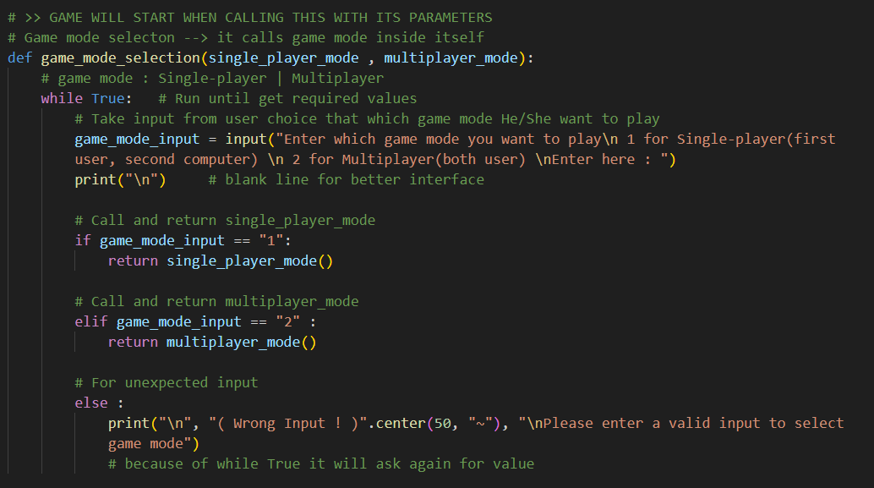

**2. game_round_selection()**

**Purpose**: Allows the user to select the number of rounds for the game (Finite or Infinite).

**Returns:**

* For Finite rounds, returns the number of rounds (must be odd and greater than or equal to 3).
* For Infinite rounds, returns a large value (10**99).

**Usage:**

* Takes user input to determine the round mode.

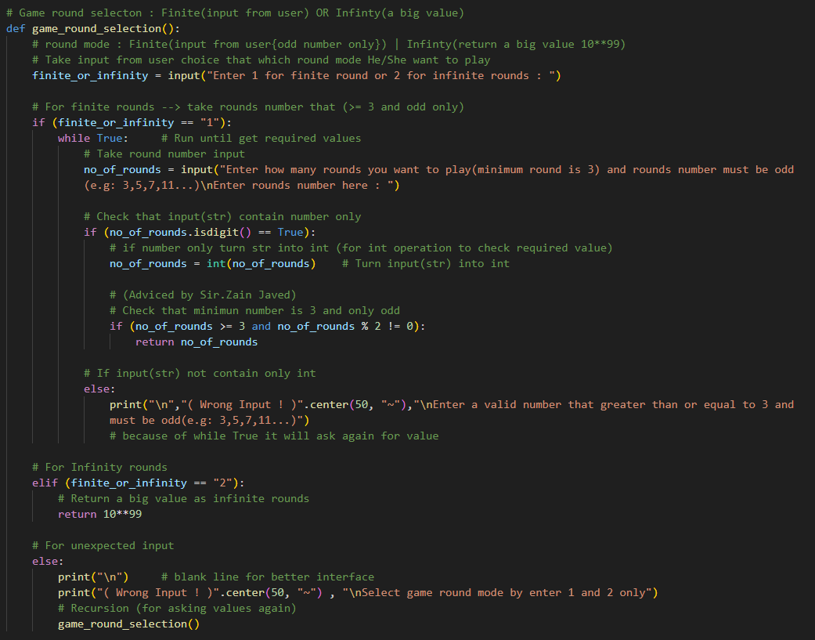

c**3. game_logic(player1_name, player1_ans, player2_name, player2_ans)**

**Purpose:** Implements the logic to determine the winner of each round based on player choices.

**Parameters:**

**player1_name:** Name of the first player.

**player1_ans:** Choice of the first player (1 for Snake, 2 for Water, 3 for Gun).

**player2_name:** Name of the second player.

**player2_ans:** Choice of the second player (1 for Snake, 2 for Water, 3for Gun).

**Returns:**

* 0 for a draw, 1 if player1 wins, and 2 if player2 wins.

**Usage:**

* Compares the choices and prints the result of each round.

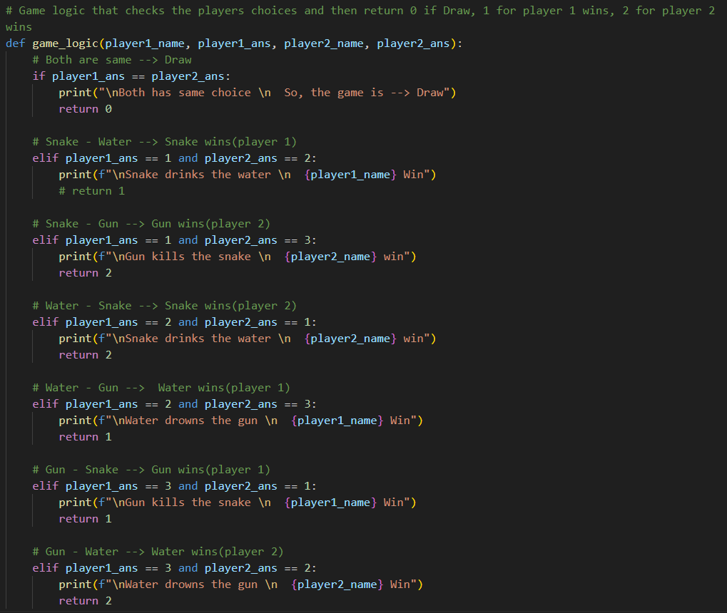

**4. players_choice_take_and_check(player1_name, player2_name, game_mode)**

**Purpose:** Takes player choices for each round based on the game mode.

**Parameters:**

**player1_name:** Name of the first player.

**player2_name:** Name of the second player.

**game_mode:** Indicates the game mode (Single Player or Multiplayer).

**Returns:**

* For Single Player mode, returns the choices of the player and the computer.
* For Multiplayer mode, returns the choices of both players.

**Usage:**

* Takes user input for choices within specified ranges.

**Player’s choices take and check For Single-player** 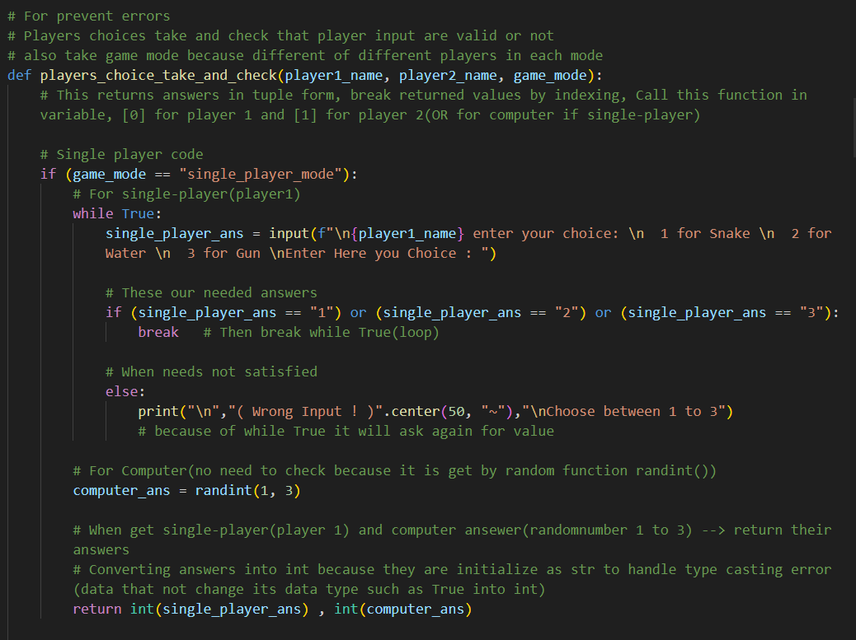­­

**Player’s choices take and check For Multiplayer-player**

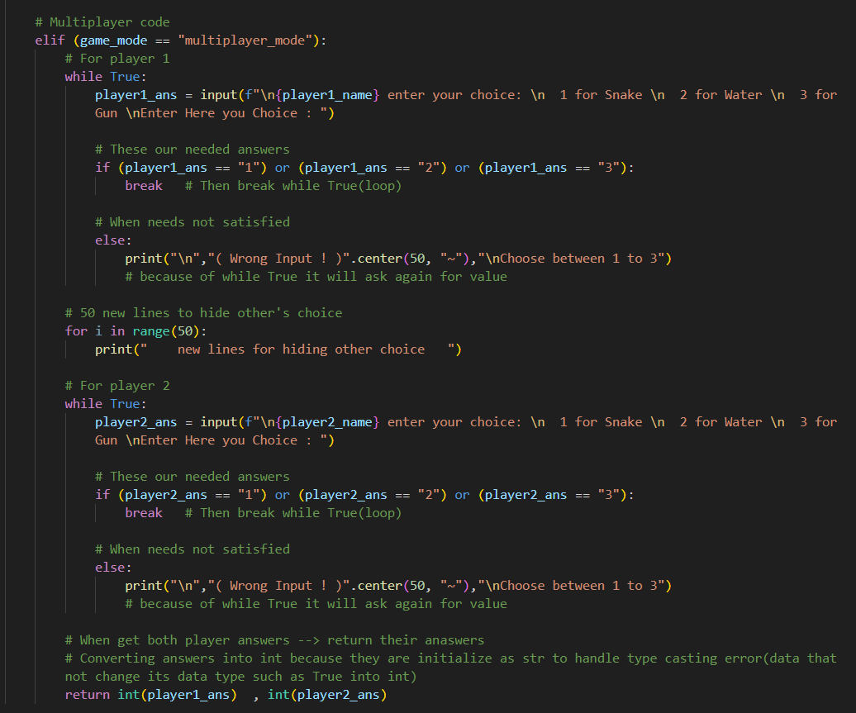

**\***Keep in mind that both above both code snippets are part of players_choice_take_and_check()

**5. single_player_mode()**

**Purpose:** Implements the Single Player game mode.

**Returns:**

* Calls the Results function to display the final result.

**Usage:**

* Takes player and computer choices for each round.
* Calculates and accumulates points.
* Prints results after each round.

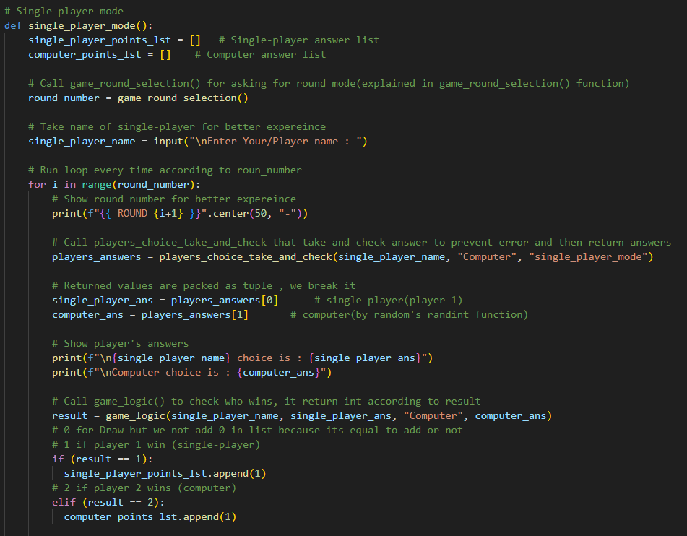

**\*Continued**

When each round complete asking for that player wants to continue game *or* want to **quit** game

If all rounds completed or player quit game then we **return Results** (7th function)

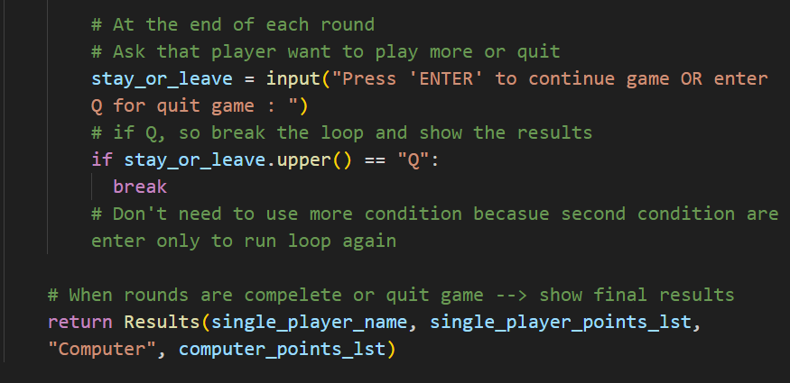

**\***This above *single-player code’s* snippets is also same for *multiplayer_mode* but arguments of **Results** in *multiplayer_mode* are different because variables names are different

**6. multiplayer_mode()**

**Purpose:** Implements the Multiplayer game mode.

**Returns:**

* Calls the Results function to display the final result.

**Usage:**

* Takes choices from both players for each round.
* Prints results after each round.

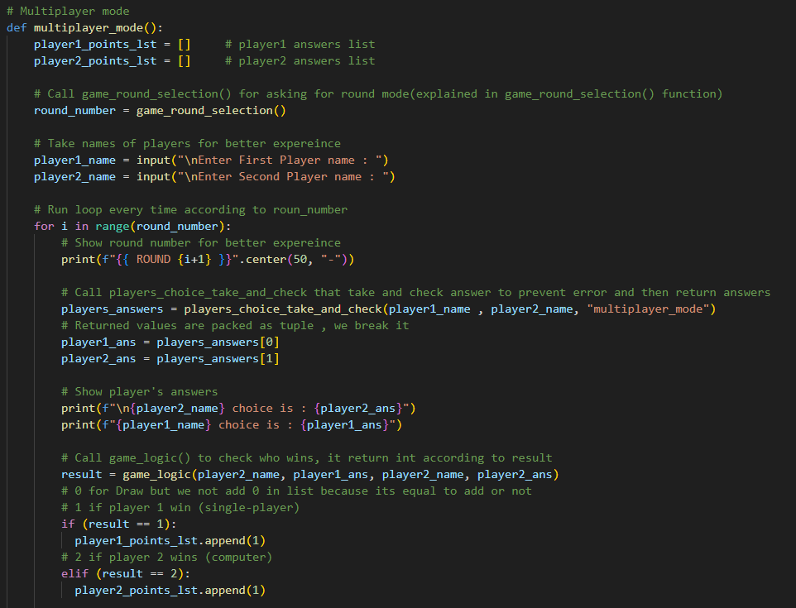

**\*Continued**

When each round complete asking for that player wants to continue game *or* want to **quit** game

If all rounds completed or player quit game then we **return Results** (7th function)

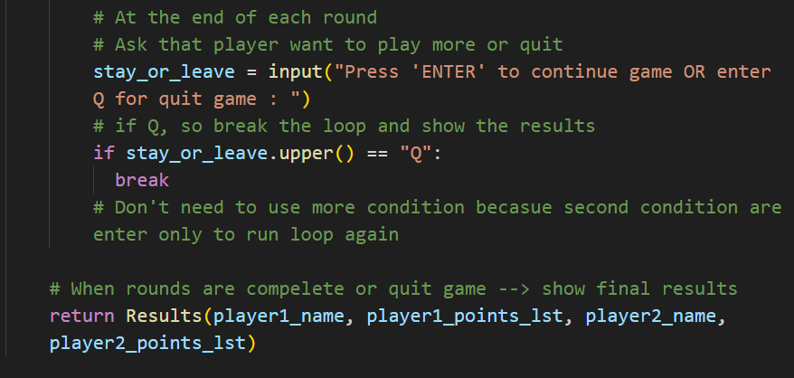

**\***As above said this snippet of code is almost same as *single-player mode’s* code but arguments of **Result** are different !

**7. Results(player1_name, player1_ points_lst, player2_name, player2_ points_lst)**

**Purpose:** Displays the final result of the game.

**Parameters:**

**player1_name:** Name of the first player.

**player1_points_lst:** List of points scored by the first player.

**player2_name:** Name of the second player.

**player2_ points_lst:** List of points scored by the second player.

**Usage:**

* Calculates the total points for each player.
* Prints the winner or declares a draw.

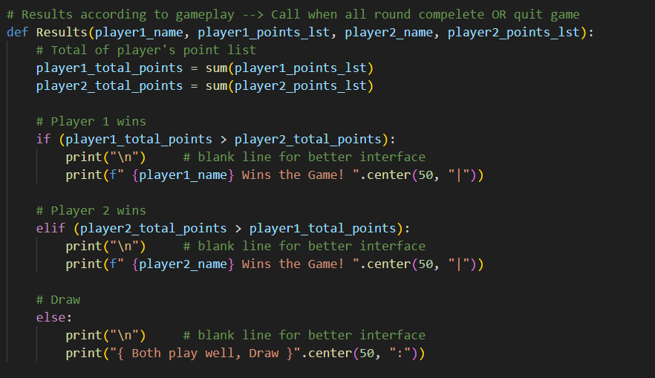

**END – Credits**

At the end of program displays credits for the developer and a thank-you message for the user

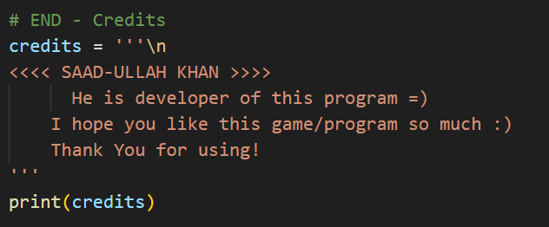

Printed at the end of the program.

*A beautiful ending ☺*

**XXX --- XXX --- XXX**